pip install -r requirements.txt
- Install provided firmware (see folder “Network Level Energy Measurement, Optimization and Prediction/Node-Minilamp-Firmware”) on Node and Mini Lamp (flash using Arduino IDE, Board Adafruit nrf82833 for node and Seeed Arduino nRF52840 for gateway. You may need to install the required libraries and hardware files which are available at: Arduino_hardware_libraries_needed.zip

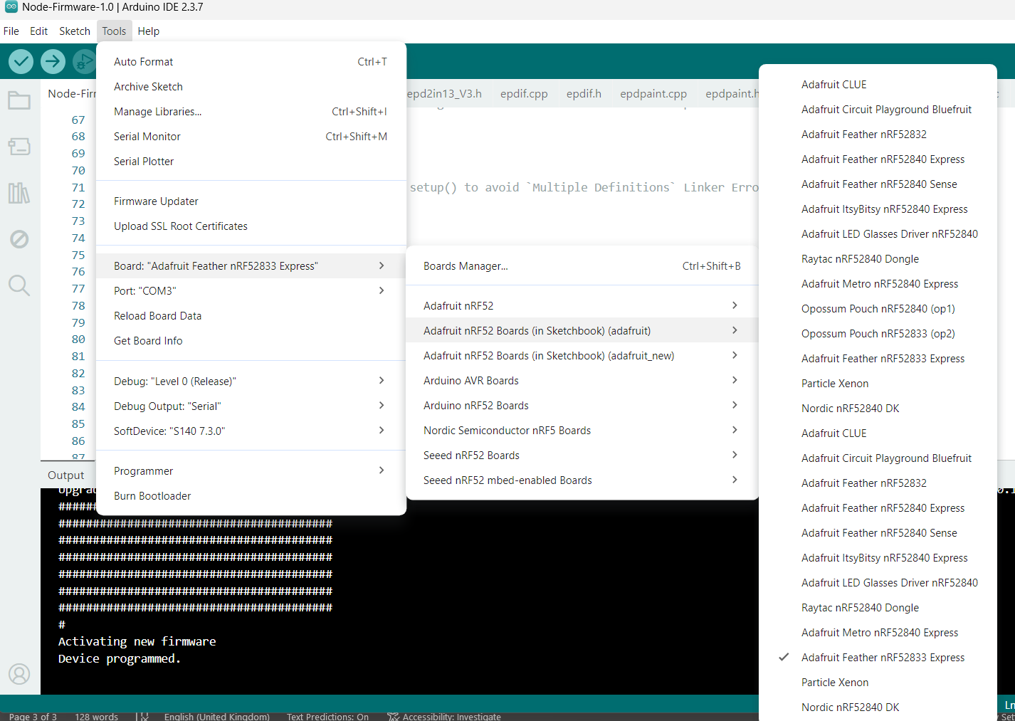
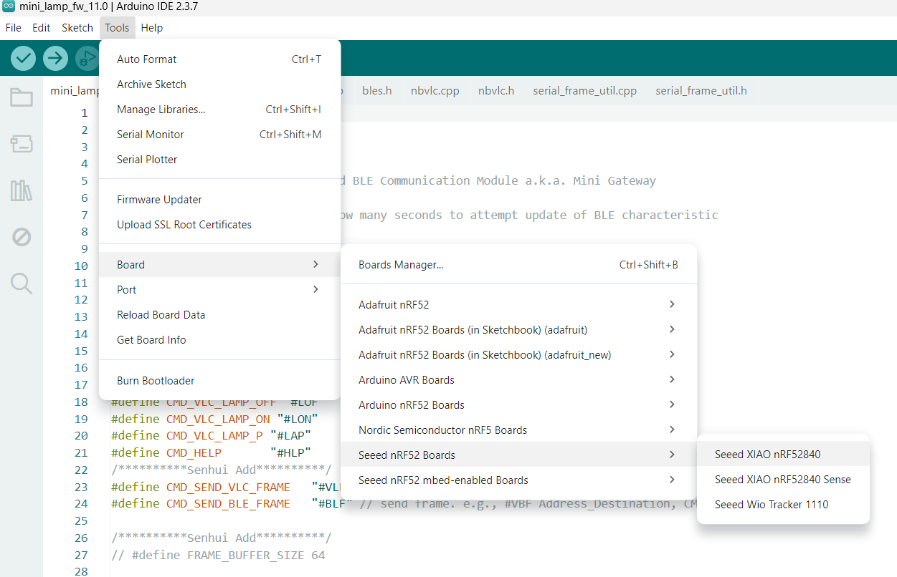
- Connect each node and each gateway to a PPK2 power profiler (using power and GND leads), and run USB cable from nodes and gateways to Hub using modified cabling setup, where the node and mini lamp are powered by PPKII. The USB cables connected to node or mini lamp do not provide power as per hardware modifications performed, only used for command transmission/reception. A common ground (GND) black cable is also connected to PPKIIs.
- Connect PPK2 power profilers to USB as well.
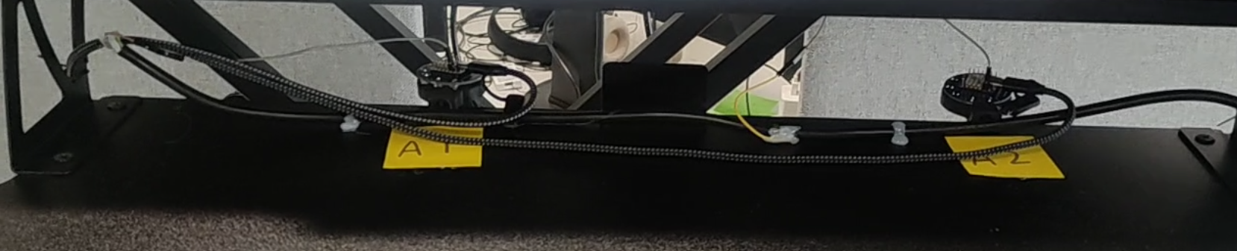
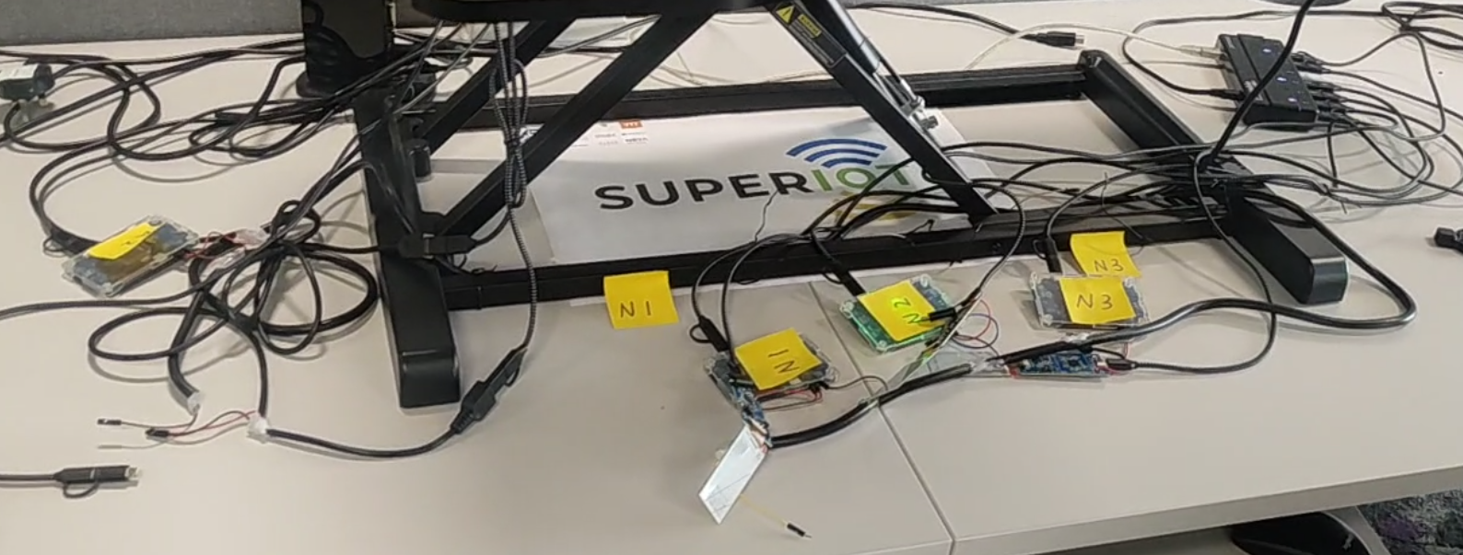

In VS code, open directory.
select interpreter (Ctrl+ Shift + P)
Python-select interpreter
+create virtual environment
Venv
Delete and Recreate
Python 3.11 C:\****
Select requirements.txt

TESTING FOR 1 NODE and 1 GATEWAY
Run python PPK2-Python.py in terminal (for node current measurements). Following window will appear. For each node and mini lamp in your measurement setup, you will need to open a separate instance of the App. Preferable to run all apps instances on the same PC via a USB Hub if many devices (for global time synchronisation).

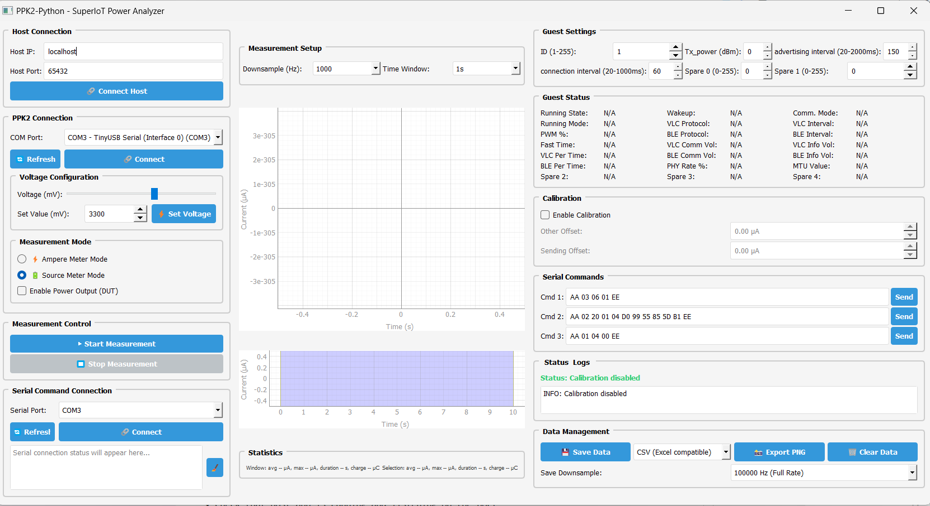

Suggestion:
IDs in Guest Settings usually set up as <10 for nodes, >10 for mini lamps (but user can define any IDs)
  - Click Refresh, Select COM Port in “PPKII Connection”) for PPKII power profiler connected to the node (e.g. COM5 – nRF Connect USB CDC ACM (COM5))
  - Click Connect
  - Set Voltage (3300 mV for NODE)
  - Source Meter Mode (Check “Enable Power Output (DUT)”)
  - Click Start Measurement (default resolution 100 kHz)
  - PPKII power profiler will turn RED
  - Node will be running in an Idle mode at this point but is not activated until serial port is connected (that is, node’s firmware is not activated).
  - Click “Connect” serial port of node in “Serial Command Connection” (Refresh if needed, note, this is different Com port than the PPK2 connection port). When you click Connect, parameters in “Guest Status” will be updated as per node’s current parameters configured in its firmware. Note, before you Connect you can also configure parameters like “Tx_power”, “advertising interval”, “connection interval”, etc in the node’s firmware first. However, you need to flash the firmware on the node (same for gateway) with desired parameters if you want to change parameters in Guest settings (else use default).
  - Use Serial commands section in App for activating different node’s operations. Check the “Commands_node.txt” and “Commands_minilamp.txt” files for list of commands you can send from node to gateway in uplink or from gateway to node in downlink. For, example on node’s App, send command “AA 01 04 00 EE” for node to go to deep sleep (you will notice “Running State” in “Guest Status” has changed. After a while, the node will wake-up again (automatic as per firmware). Note: If you send deep sleep command to node, the node serial port will be disconnected (but not the current measurement). Then press Connect again in Serial Command Connection on the Node App after the node has woken up.
  - Save Data (choose desired resolution) may take a while depending on amount of data logged.
  - Stop Measurement
  - Clear Data

For recording the measurement on the mini lamp gateway, open another terminal, and run python PPK2-Python-Minilamp.py. The default ID is 10.
Note: For mini lamp set voltage to 5000 mV.

PARSING DATA FILES
#####################################################################
- When you click Save Data (raw) on App, it will be saved as several parts (suggestion: save data for each node and gateway/access point in separate folders)
- Run “plot_saved_raw_enhanced.py” to refine/correct/realign the raw data. The new generated files will have the “_refined” text appended to the filenames. You may move the files to a new folder.
- Preprocess the refined data in different steps using scripts provided in “Predictor and Optimizer\Preprocess_dataset” folder.

